Link online: <https://docs.google.com/document/d/1DgnUJEdUZyZUmknL58c_vHU_OJP47aaXrfbiYru3PeA/edit#heading=h.dnm8nt6tn67e>

# Prepare Environment

* 1. PHP 7 or above
  2. Mysql v5.7
  3. Nginx
  4. Git - For clone and update source code.
  5. Composer (if setup source code using GIT)
  6. Mysql Yog/ Navicat/ Mysql WorkBench - For manage Database

# Setup

## Pull/get source

* + 1. Using Git
* ssh into server
* go to directory with be used for placing source code. Example **/products**
* execute command:
  + git clone <https://gitlab.com/SOS_Di4l/sos_backend.git>
* then input gitlab user name and password.
  + 1. Using source code in zip
* unzip source code.
* Copy folder “sos_backend" to directory with be used for placing source code. Example **/products**

## Config source

* + 1. Run Composer ( Use for deploy with GIT only)
* Cd to sos_backend
* Execute: composer install
* wait to finish
  + 1. Generate app key
* Cd sos_backend
* Run “ php artisan key:generate”

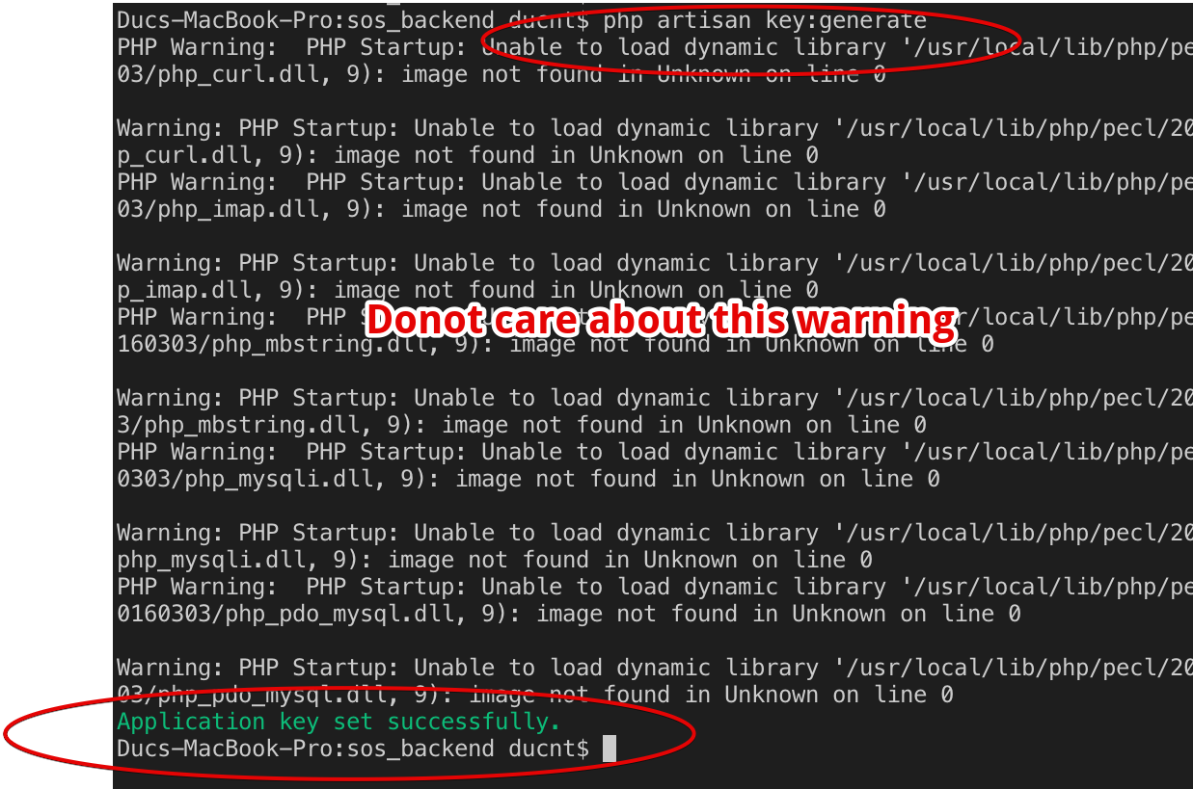

* + 1. Update config
* Copy file .env.example to new file name .env
* Edit file .env

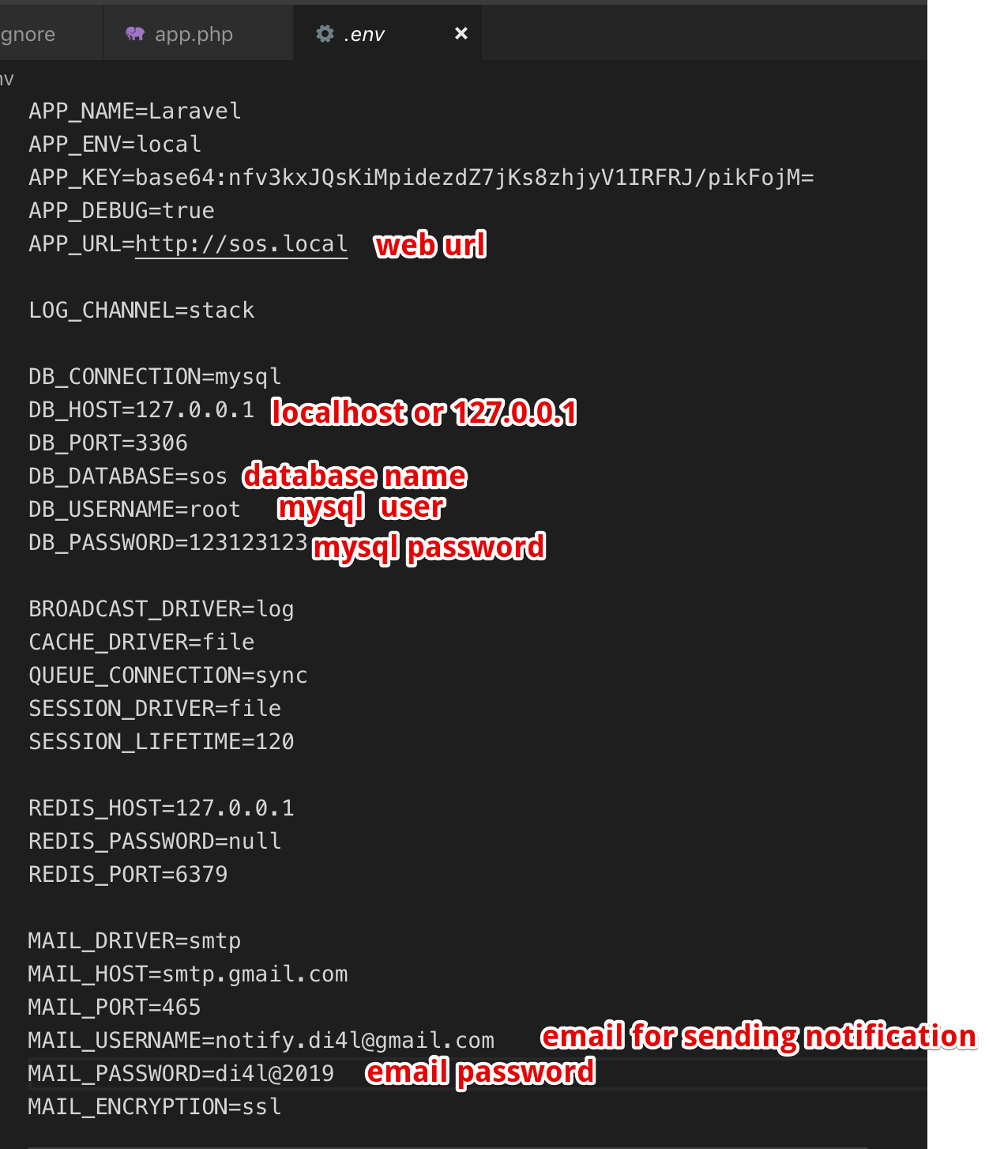

## Config db & init db

* Open mysql workbench ( or other mysql management software)
* Connect to server
* 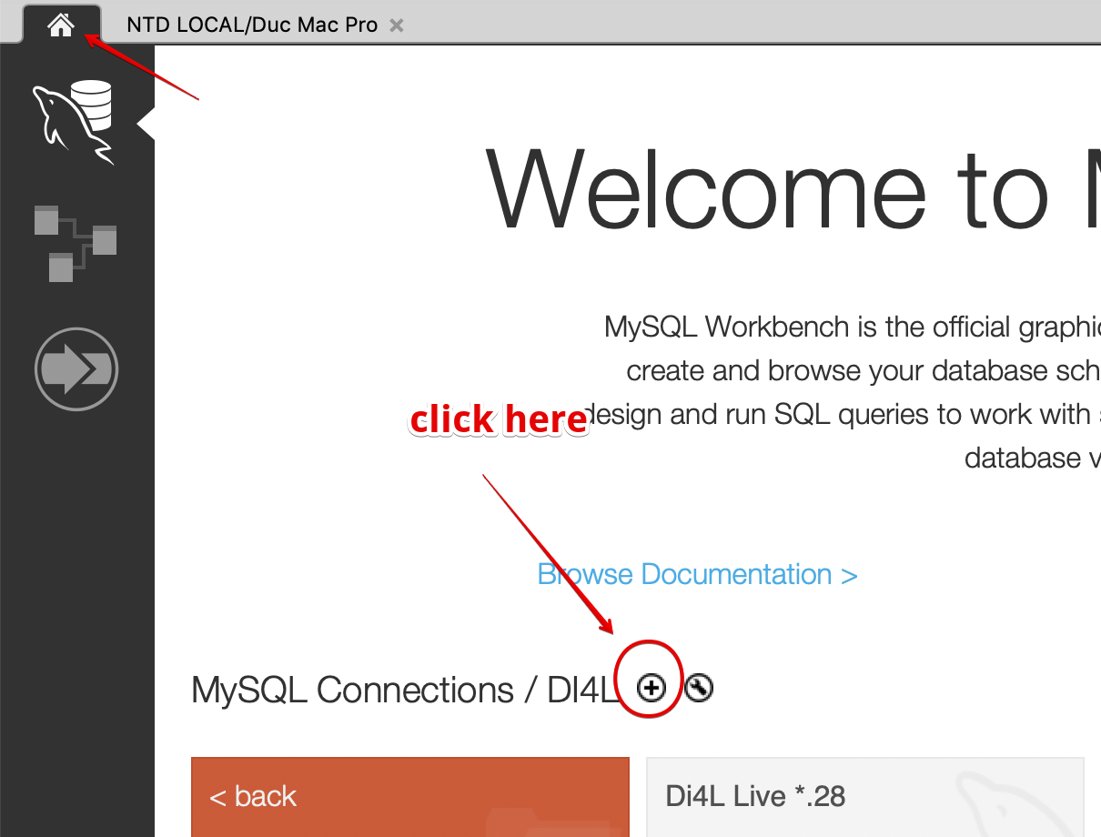
* 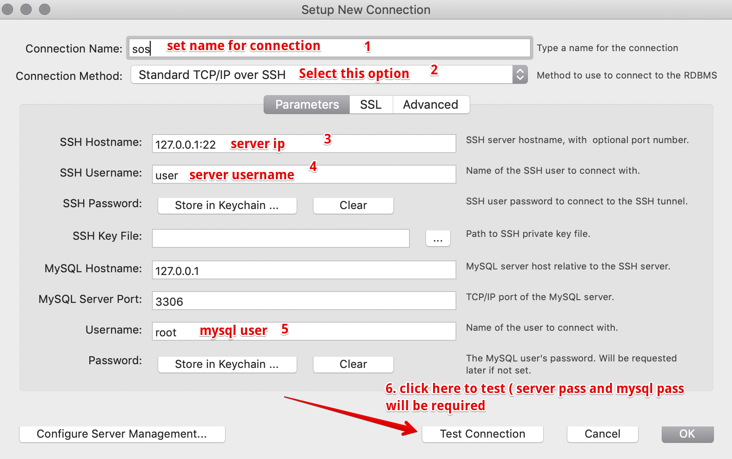
* After test connection, click ok to access mysql management
* Create new db call “sos” - save with config in .env file
* 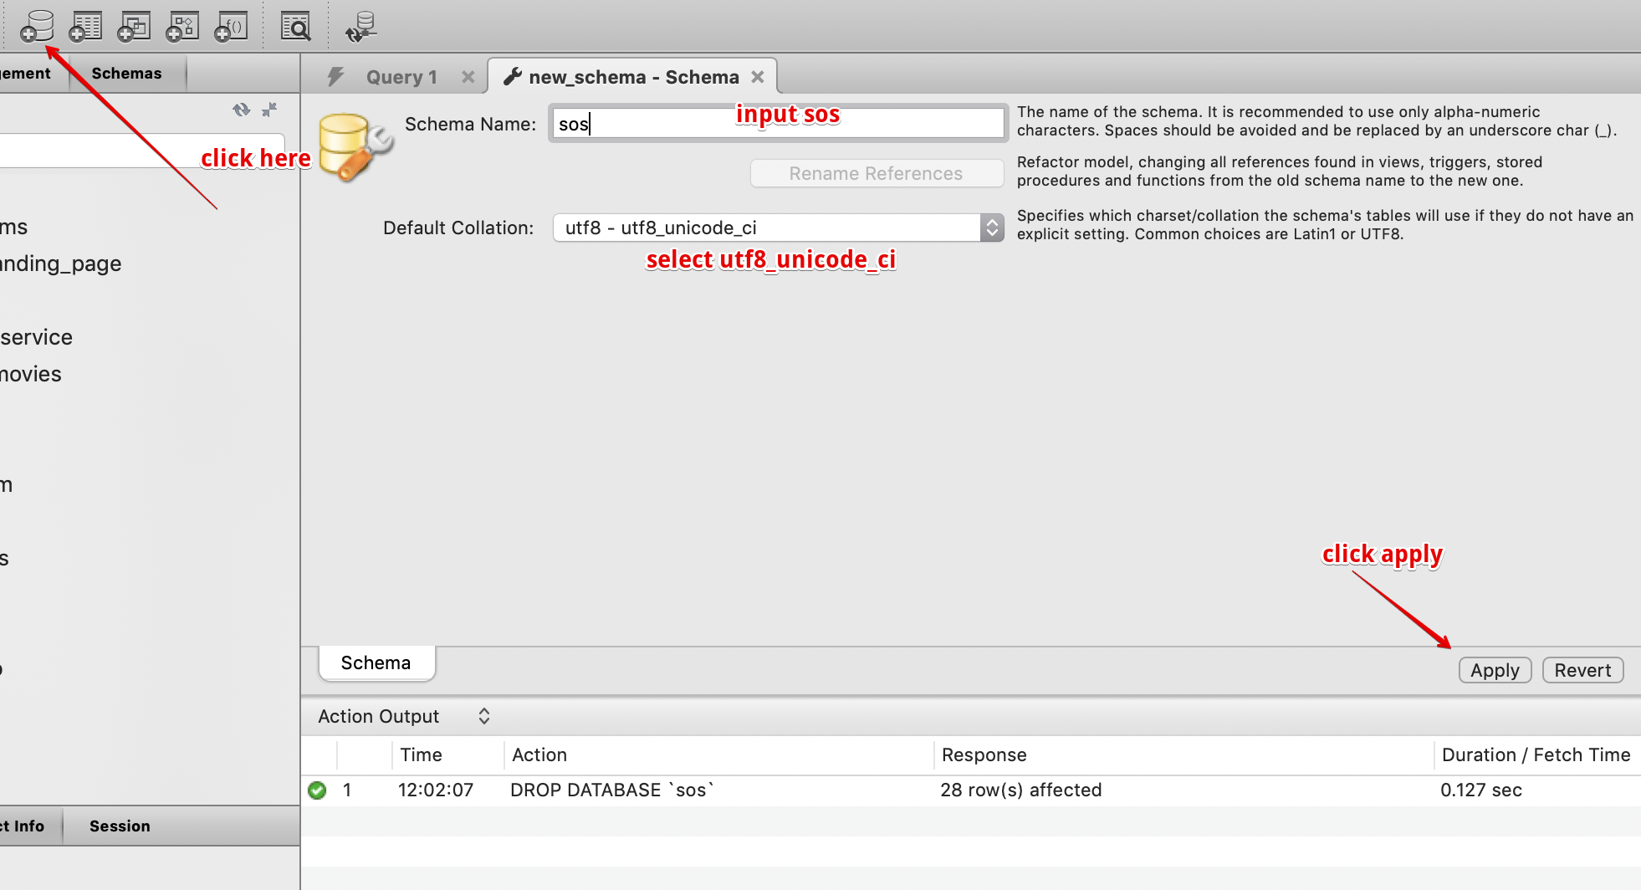
* Go to source code at /sos_backend/database, copy all content in fulldata.sql
* 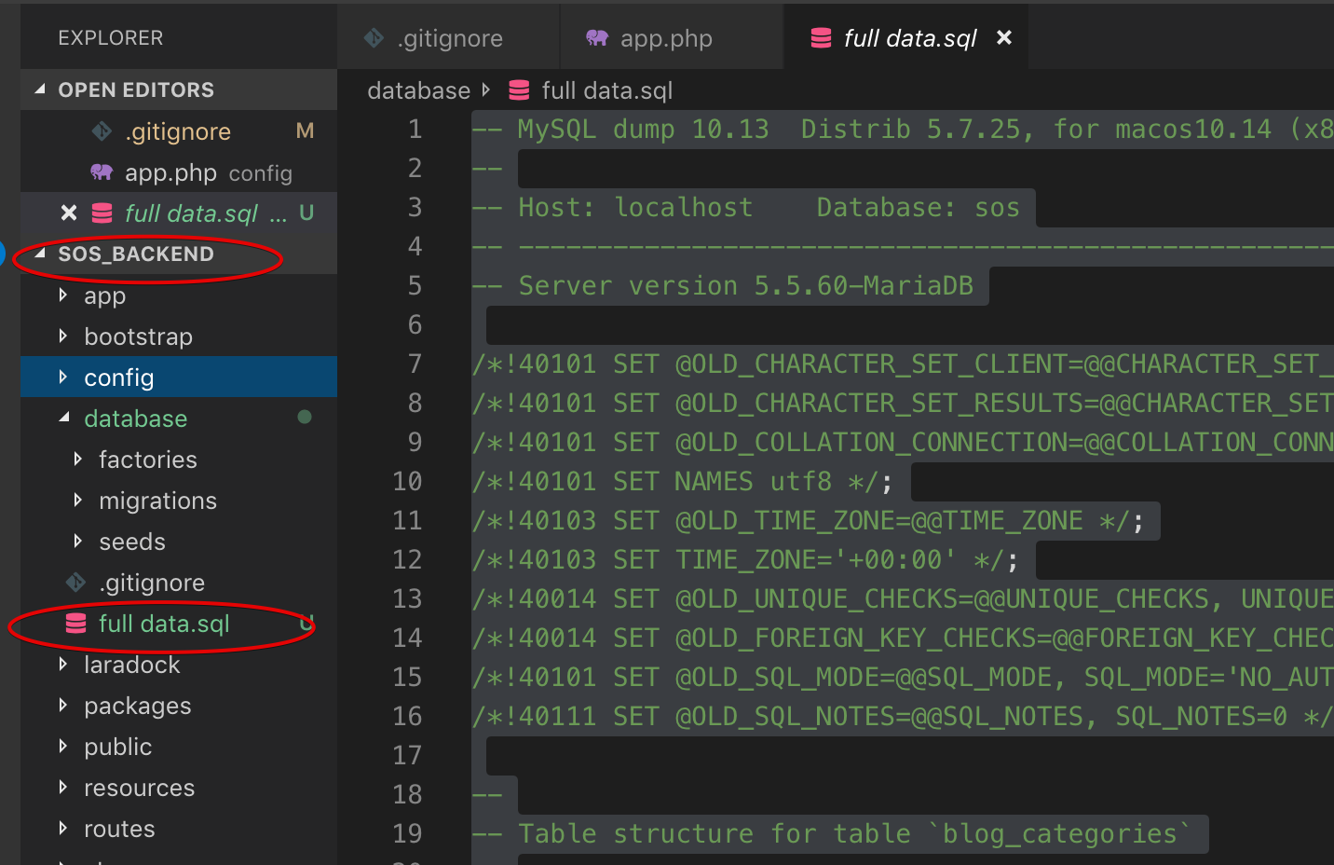
* Come back mysql workbench
* 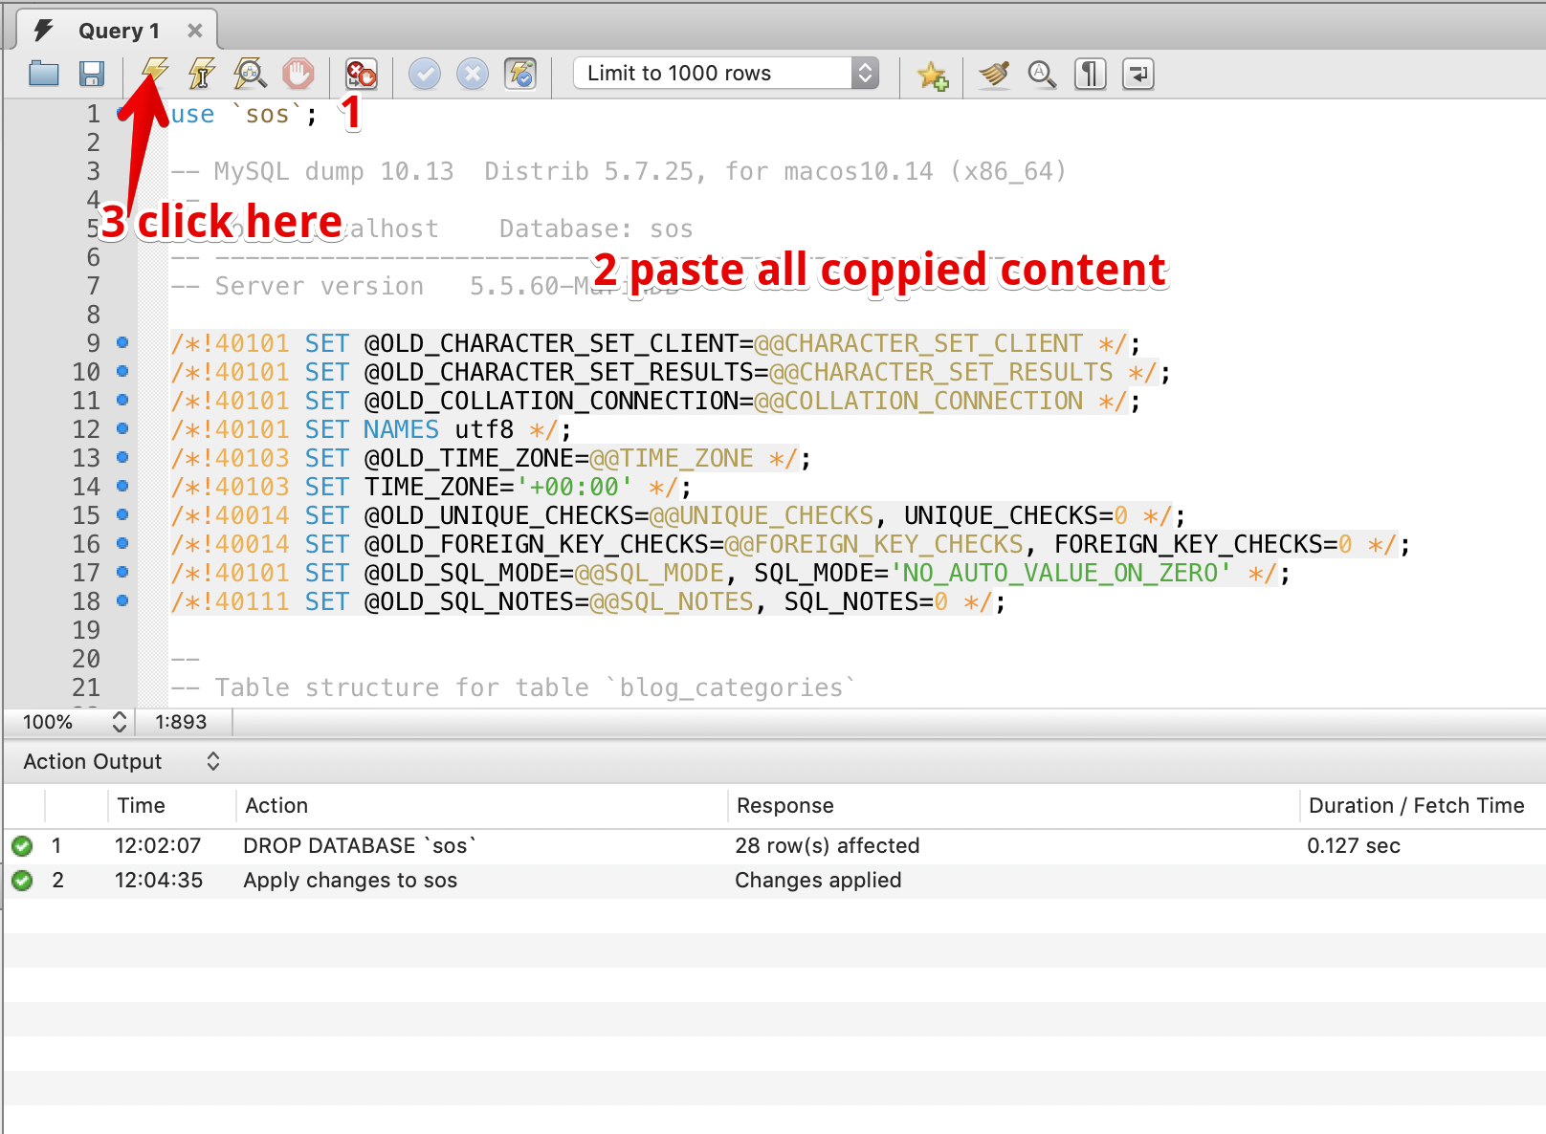

## Config vhost

* DNS domain to server ip.
* Ssh into server.
* Run “cd /etc/nginx/conf.d”
* Run “touch sos.conf”
* Paste below content into sos.conf

server {

listen 80;

server_name **sos.local; //change domain**

root /Users/ducnt/Projects/www/sos_backend/public/; //change location of source code

index index.php index.html index.htm;

client_max_body_size 2G;

fastcgi_buffers 64 4K;

access_log /Users/ducnt/Projects/www/sos_backend/storage/logs/http_access.log combined;

error_log /Users/ducnt/Projects/www/sos_backend/storage/logs/http_error.log;

#change location to save logs

location / {

try_files $uri $uri/ /index.php?$query_string;

}

location ~ \.php$ {

try_files $uri /index.php =404;

fastcgi_split_path_info ^(.+\.php)(/.+)$;

fastcgi_pass 127.0.0.1:9000;

fastcgi_index index.php;

fastcgi_param SCRIPT_FILENAME $document_root$fastcgi_script_name;

include fastcgi_params;

}

}

* Save sos.conf
* Run “nginx -t” // check nginx config if it ok or not
* Run “service nginx reload”
* Run “service nginx restart”

Goto browser and type your domain